Name - Manish kumar
Roll no – 2303b09903
Sub - oscn
Course – MCA
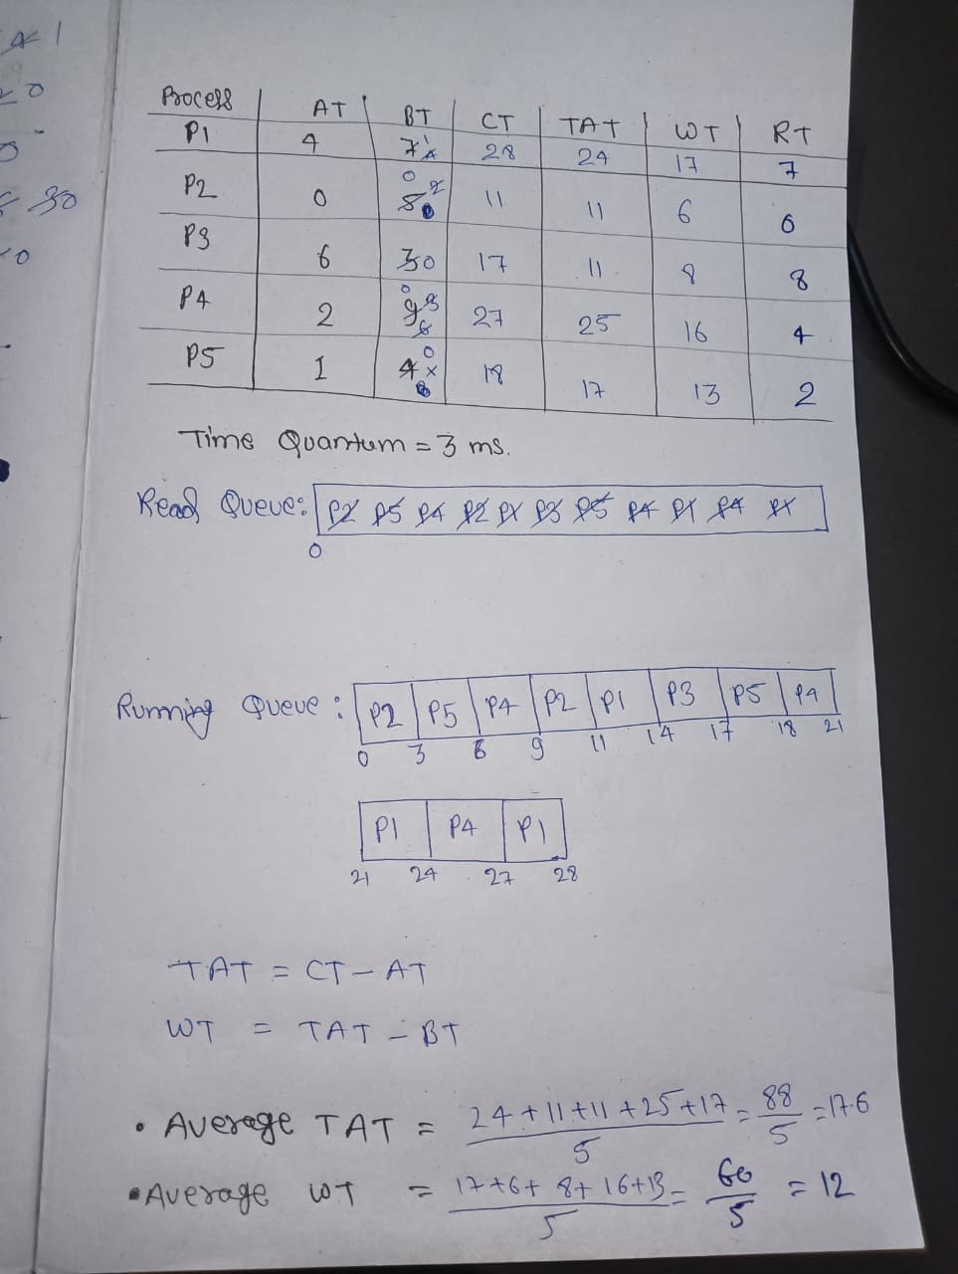
CODE
#include <stdio.h>

#define MAX 50

int main() {
int n = 5;
int tq = 3;

int at[5] = {4, 0, 6, 2, 1};
int bt[5] = {7, 5, 3, 9, 4};

int rem[5], ct[5], tat[5], wt[5], rt[5];
int started[5] = {0}, inQueue[5] = {0};

int queue[MAX];
int front = 0, rear = 0;

for (int i = 0; i < n; i++)
rem[i] = bt[i];

int time = 0, completed = 0;

// Find first arriving process
int minAT = 999, first = -1;
for (int i = 0; i < n; i++)
if (at[i] < minAT)
minAT = at[i], first = i;

time = minAT;
queue[rear++] = first;
inQueue[first] = 1;

while (completed < n) {

if (front == rear) {
time++;
for (int i = 0; i < n; i++)
if (at[i] <= time && !inQueue[i]) {
queue[rear++] = i;
inQueue[i] = 1;
}
continue;
}

int p = queue[front++];

// First response
if (!started[p]) {
rt[p] = time - at[p];
started[p] = 1;
}

// Execution
if (rem[p] > tq) {
rem[p] -= tq;
time += tq;
} else {
time += rem[p];
rem[p] = 0;
ct[p] = time;
completed++;
}

// Add newly arrived processes (before requeueing p)
for (int i = 0; i < n; i++) {
if (at[i] <= time && !inQueue[i]) {
queue[rear++] = i;
inQueue[i] = 1;
}
}

// If p still needs CPU -> put at end
if (rem[p] > 0) {
queue[rear++] = p;
}
}

// Compute TAT and WT
for (int i = 0; i < n; i++) {
tat[i] = ct[i] - at[i];
wt[i] = tat[i] - bt[i];
}

// Output
printf("\nProcess\tAT\tBT\tCT\tTAT\tWT\tRT\n");
for (int i = 0; i < n; i++)
printf("P%d\t%d\t%d\t%d\t%d\t%d\t%d\n",
i+1, at[i], bt[i], ct[i], tat[i], wt[i], rt[i]);

return 0;
}

OUTPUT
